***Abstract*— Inconsistent referee decisions can significantly impact the outcome of football matches, leading to controversy and frustration among players, coaches, and fans. To address this issue, we propose Fairplay AI, a deep learning-based decision support system designed to assist referees in making accurate and fair decisions. Our approach leverages a comprehensive dataset of football match images, referee decisions, and contextual information to train a convolutional neural network (CNN) model. The model can analyze game footage and predict referee decisions in real-time, providing a**

**valuable tool for referees to improve their accuracy and consistency. We outline the development of Fairplay AI, from data collection and preprocessing to model training and validation and discuss the potential benefits and limitations of our approach. Our results demonstrate the effectiveness of Fairplay AI in enhancing referee decision-making, and we propose its deployment as a web-based application to support referees in live matches.**

***Keywords—*** ***FairPlay AI, deep learning, referee decisionmaking, football, convolutional neural networks (CNNs), computer vision***

I. INTRODUCTION

# A. Problems with the modern game of football

The integrity of football, one of the world's most popular sports, is frequently challenged by the subjectivity and inconsistency of referee decisions. These decisions can significantly influence the outcome of matches, leading to disputes among players, coaches, and fans. As the game evolves, so too do the complexities involved in officiating, necessitating a more systematic and reliable approach to decision-making. Traditional methods of officiating are often hindered by human error, biases, and the fast paced nature of the game, which can lead to misinterpretations of critical moments on the field.

# B. The solution for the problems

In recent years, advancements in artificial intelligence (AI) and machine learning have opened new avenues for enhancing decision-making processes across various domains, including sports. Deep learning, particularly using Convolutional Neural Networks (CNNs), has shown remarkable success in image classification and recognition tasks, making it a promising tool for analysing football match footage. By harnessing the power of AI, we can develop a decision support system that aids referees in making informed and accurate calls during matches.

This paper presents Fairplay AI, an innovative project aimed at improving the fairness and consistency of referee decisions in football through the application of deep learning techniques. We detail our methodology, which includes data collection from open-source datasets, preprocessing of

|  |  |  |
| --- | --- | --- |
|  | Fairplay AI |  |
|  | Chetan Rajkumar  *Dept. of Computer Science*  *(of Affiliation)*  *Manipal Institute of Technology*  *(of Affiliation)*  Bengaluru,Karnataka chetanraj2801@gmail.com |  |

images, model training, and evaluation. Our goal is to create a robust AI model that not only assists referees in real-time decision-making but also enhances the overall integrity of the sport. As we progress through the phases of this project, we aim to validate our model's performance and explore its potential deployment as a web application, making it accessible to football clubs, leagues, and fans alike.

Through this initiative, we aspire to contribute to the ongoing discourse around the use of technology in sports officiating and to provide a foundation for future developments in AI-powered decision support systems.

II. METHODOLOGY

# A. Data collection and processing

* Dataset Organization: The dataset is organized into two classes, “foul” and “non-foul,” with labelled folders with 400 images for each. Images were sourced from sports video frames, where each frame represents a significant moment potentially depicting foul play.
* Image Validation: The dataset validation script uses OpenCV to verify each image format, removing unsupported types (only JPEG, JPG, BMP, and PNG formats are retained).
* Cleaning & Transformation: All images are resized to 256x256 pixels to standardize input dimensions across the CNN model.
* Normalization: Pixel values are normalized to [0, 1] by dividing by 255, which helps improve model stability during training.
* Data Augmentation: To enhance model generalization, data augmentation techniques like rotation, flipping, and brightness adjustment are applied, simulating diverse conditions that might be encountered during gameplay.

# B. Model Architecture

* Convolutional Layers: The CNN model is built with four convolutional layers, starting with 16 filters in the first layer and increasing to 32, 64, and finally 128 filters. Each layer uses a 3x3 kernel and ReLU activation to capture visual patterns associated with fouls, such as the positioning of limbs and the proximity between players.
* Batch Normalization and Dropout Layers: Applied after each convolutional layer to improve model performance and training stability.
* Dropout Layers: Introduced after each convolutional block with dropout rates ranging from 0.25 to 0.5, reducing overfitting by randomly disabling neurons during training.
* Fully Connected Layers:
* The flattened feature map is passed through a dense layer with 256 units and ReLU activation. A final dense layer with a sigmoid activation function outputs probabilities for binary classification, predicting whether an image is a foul (1) or non-foul (0).
* Model Compilation: The model is compiled with the Adam optimizer and binary cross-entropy loss function, with accuracy as the primary metric.

# C. Training and validation

* Data Splitting: The dataset is divided into training (70%), validation (20%), and testing (10%) sets. This ensures a balanced split and adequate representation for each class.
* Early Stopping: EarlyStopping monitors validation loss, stopping training when there is no improvement over three epochs to prevent overfitting.
* Learning Rate Scheduler: A LearningRateScheduler is used, dynamically adjusting the learning rate after the fifth epoch to promote smoother convergence.
* Performance Metrics: Precision and accuracy metrics are used to track the model’s ability to classify fouls effectively, with precision being critical in minimizing false positives (incorrectly labelling a non-foul as a foul). D. Streamlit Deployment
* User Interface Setup: Streamlit provides an interactive interface where users upload an image and receive a

prediction on foul status with a confidence score. The simple, user-friendly design makes it accessible to non-technical users.

* Real-Time Feedback: With GPU processing, predictions are generated quickly, providing nearly instant feedback on uploaded images, aligning with the demands of live sports analysis.

III. RESULTS

# A. Accuracy and Precision

The model achieves 0.66667 accuracy and 0.9 precision on the test set, indicating a high ability to correctly identify fouls and non-fouls. Precision is especially valuable for foul detection, where false positives could disrupt gameplay.

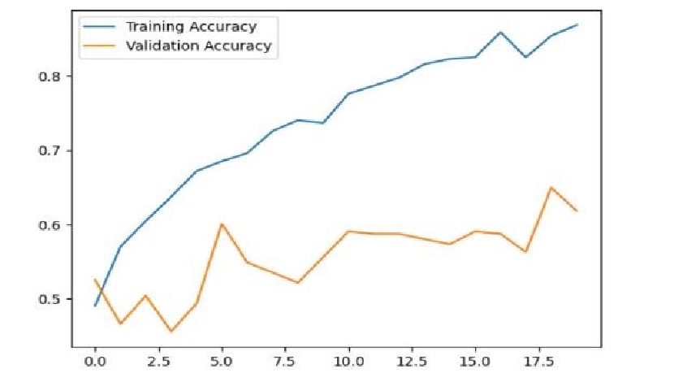

Fig. 1. Example of a figure caption. (*figure caption*)

# B. Training and Validation Loss/Accuracy Curves

Plots for loss and accuracy show steady improvements, with the model reaching a stable validation accuracy and minimal overfitting, supported by dropout layers and batch normalization.

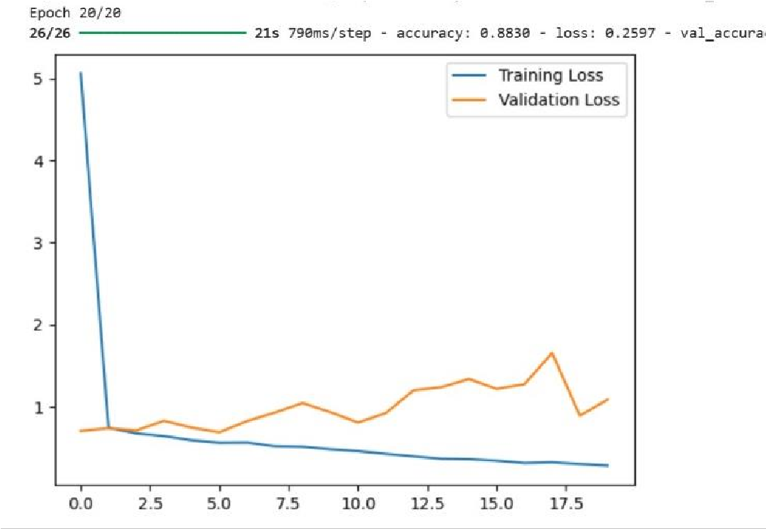

Fig. 2. Graph showing training and Validation Loss

*C. Sample Predictions* Sample images are displayed with the model’s predictions. For example, the model correctly identifies clear fouls where one player’s actions are aggressive or intrusive and non-fouls where interactions are minimal. These examples showcase the model’s ability to generalize across typical sports actions.

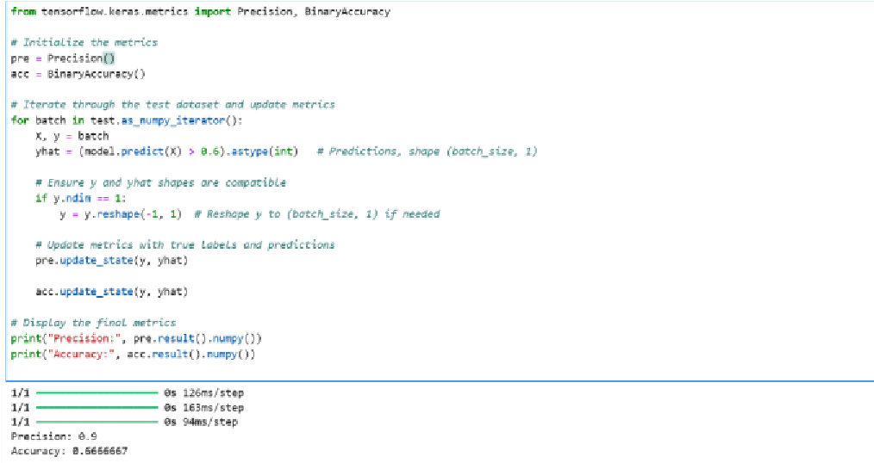

Fig. 3. Code Snippet for Sample Prediction

# D. User Interface

Screenshots of the Streamlit interface demonstrate user interaction, highlighting the image upload feature and realtime foul prediction display. The simplicity of the interface makes it suitable for immediate use by sports officials or analysts.

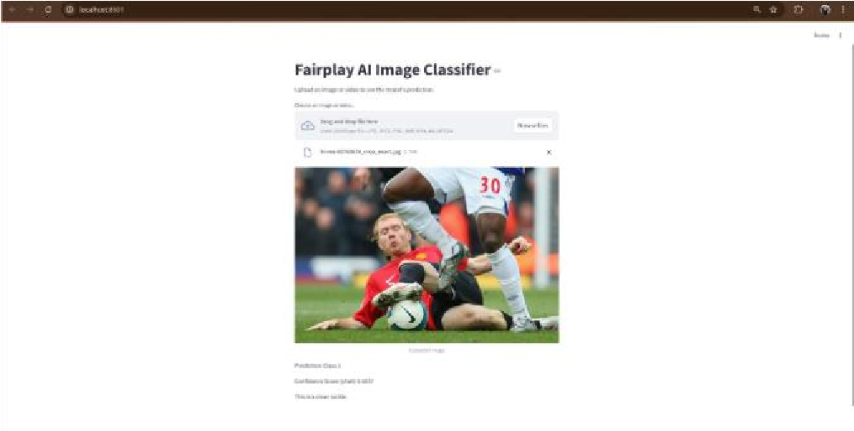

Fig. 4. Screenshot of the User Interface

IV. DISCUSSION

# A. Accuracy and Precision

The model effectively generalizes to different scenarios, accurately identifying fouls in a range of settings, from crowded areas to close-up frames. Cases where the model performs best typically feature clear body positioning indicative of foul play.

# B. Challenges

* Subjectivity in Foul Classification: Some fouls are ambiguous and challenging to classify, reflecting the subjective nature of the data labels. Further work could involve refining labels with expert input.
* Data Limitations: The dataset might lack diversity in terms of sport types and action contexts. A broader dataset would enhance model performance across different sports scenarios.

# C. Future Improvements

* Expanded Dataset and Consistent Labelling: A larger, more diverse dataset would improve generalizability, as would standardized labelling criteria for fouls.
* Advanced CNN Architectures: Incorporating advanced architectures such as transfer learning (e.g., ResNet) may yield better results by leveraging pretrained models on large image datasets.
* Video Processing for Continuous Analysis: Future iterations could include video input, enabling continuous analysis and capturing sequential context for better foul detection.

V. CONCLUSION

* Contributions of Fairplay AI: Fairplay AI presents a promising approach to automated foul detection, supporting officials and analysts in making datadriven, consistent calls. The tool is designed for use in real time, making it an ideal complement to existing decision-making processes in sports.
* Impact on Sports Analytics: By providing near-instant feedback on fouls, Fairplay AI has the potential to influence the future of sports analytics, enhancing fairness and transparency in decision-making.
* Future Directions: Future work may focus on scaling the system to handle live video feeds, refining the model architecture, and adapting it for use across various sports.

ACKNOWLEDGMENT

We would like to express our sincere gratitude to Dr. Preeti Hebbar for her invaluable guidance and support, which has been instrumental in the successful completion of this work.

REFERENCES

1. International Journal of Information and Communication Technology, "Feature extraction method of football fouls based on deep learning algorithm"
2. IIJSR, "Prediction and Classification of Fouls in Soccer Game using

Deep Learning"

1. https://www.kaggle.com/datasets/zaikali/football-tackles
2. Streamlit Documentation. Retrieved from https://docs.streamlit.io